Week3

Lists

Amortization

Trees

Priority Queues

Comparators

Heaps

[A List ADT es az Array List az elozo hethez tartozott volna, de kifelejtettem, ugyhogy most fogom azt feldolgozni.]

The List ADT

Java interface: java.util.List, which includes the following index-based methods:

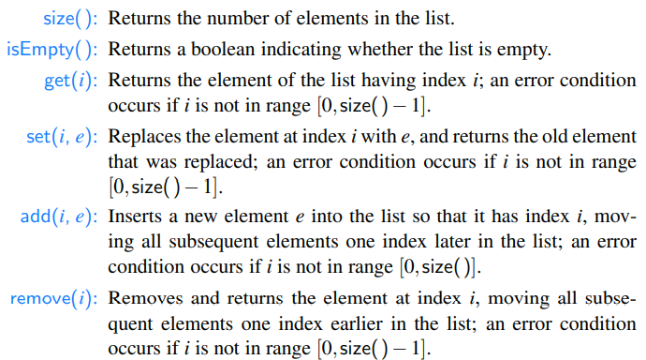

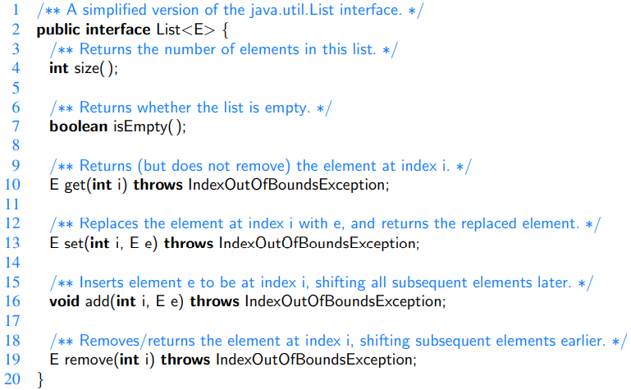

Array Lists

With bounded capacity:

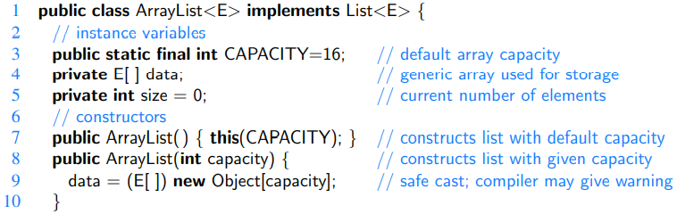

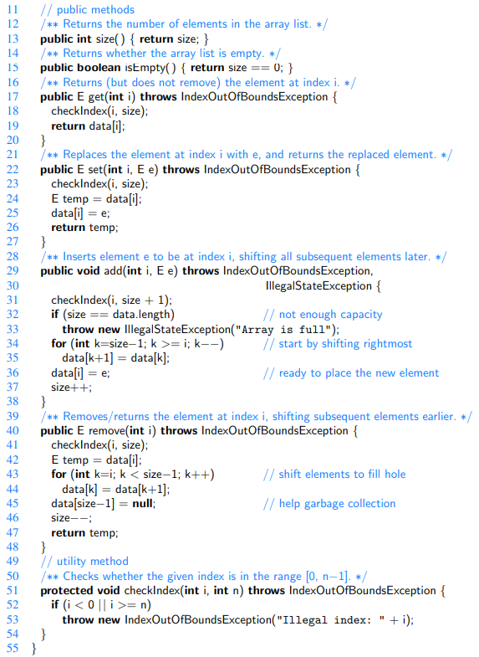

Performance of an Array-based Implementation of an Array List

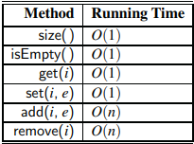

Looking more closely at add(i, e) and remove(i), we note that they each run in time O(n− i+ 1), for only those elements at index i and higher have to be shifted up or down. Thus, inserting or removing an item at the end of an array list, using the methods add(n, e) and remove(n − 1) respectively, takes O(1) time each. Moreover, this observation has an interesting consequence for the adaptation of the array list ADT to the deque ADT from Section 6.3.1. If we do the “obvious” thing and store elements of a deque so that the first element is at index 0 and the last element at index n − 1, then methods addLast and removeLast of the deque each run in O(1) time. However, methods addFirst and removeFirst of the deque each run in O(n) time.

Actually, with a little effort, we can produce an array-based implementation of the array list ADT that achieves O(1) time for insertions and removals at index 0, as well as insertions and removals at the end of the array list. Achieving this requires that we give up on our rule that an element at index i is stored in the array at index i, however, as we would have to use a circular array approach. [How would I implement this?]

Dynamic Arrays

Because the system may allocate neighboring memory locations to store other data, the capacity of an array cannot be increased by expanding into subsequent cells.

An array list instance maintains an internal array that often has greater capacity than the current length of the list. When it’s needed, it reserves a bigger array. Like when a crab moves into a larger shell.

When a bigger array is needed, this happens:

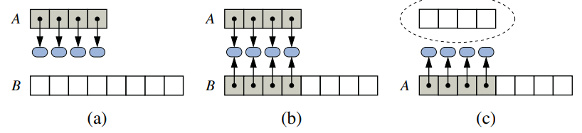

1. create new array B;
2. store elements of A in B;
3. reassign reference A to the new array.

Not shown is the future garbage collection of the old array, or the insertion of a new element.

We achieve this by the following resize() method:

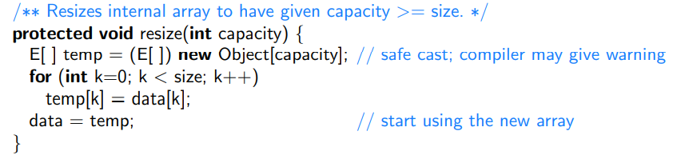

How large (capacity) should the new array be? Commonly: Twice the capacity of the original array.

We change the add() method accordingly:

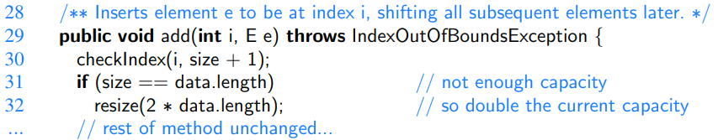

We will have two constructors for the ArrayList class. A default constructor with a capacity = 16, and a parameterized constructor where the caller can specify the capacity.

Amortized Analysis of Dynamic Arrays

We will analyze the running time of operations on dynamic arrays.

Push operation means insertion of an element to be the last element of the array list.

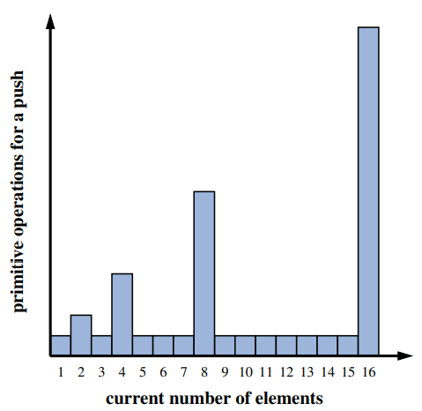

Actually the time complexity of dynamic arrays is pretty good. This is what we will show now:

Proposition: Let L be an initially empty array list with capacity one, implemented by means of a dynamic array that doubles in size when full. The total time to perform a series of n push operations in L is O(n).

Justification: Let us assume that one cyber-dollar is enough to pay for the execution of each push operation in L, excluding the time spent for growing the array. Also, let us assume that growing the array from size k to size 2k requires k cyberdollars for the time spent initializing the new array. We shall charge each push operation three cyber-dollars. Thus, we overcharge each push operation that does not cause an overflow by two cyber-dollars. Think of the two cyber-dollars profited in an insertion that does not grow the array as being “stored” with the cell in which the element was inserted. An overflow occurs when the array L has 2i elements, for some integer i ≥ 0, and the size of the array used by the array representing L is 2^i . Thus, doubling the size of the array will require 2^i cyber-dollars. Fortunately, these cyber-dollars can be found stored in cells 2^i −1 through 2^i −1.

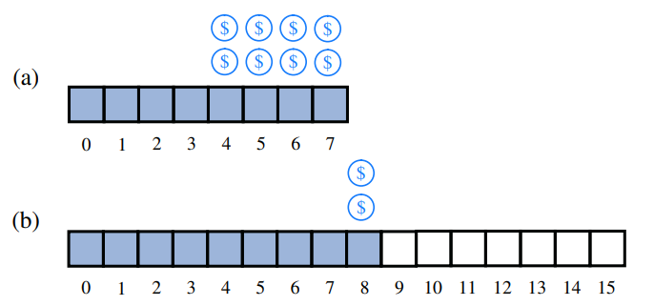

Note that the previous overflow occurred when the number of elements became larger than 2i−1 for the first time, and thus the cyber-dollars stored in cells 2i−1 through 2i − 1 have not yet been spent. Therefore, we have a valid amortization scheme in which each operation is charged three cyber-dollars and all the computing time is paid for. That is, we can pay for the execution of n push operations using 3n cyber-dollars. In other words, the amortized running time of each push operation is O(1); hence, the total running time of n push operations is O(n).

To avoid reserving too much space at once, it might be tempting to implement a dynamic array with a strategy in which a constant number of additional cells are reserved each time an array is resized. Unfortunately, the overall performance of such a strategy is significantly worse. At an extreme, an increase of only one cell causes each push operation to resize the array, leading to a familiar 1+2+3+···+ n summation and Ω(n^2) overall cost.

Memory Usage and Array Shrinking

When the increase of capacity is geometric (e.g. always double) the final array size is guaranteed to be proportional to the overall number of elements. That is, the data structure uses O(n) memory.

Deleting elements can cause problems, if we don’t shrink the underlying array.

The StringBuilder Class

StringBuilder class is storing characters in a dynamic array.

It guarantees that a series of append operations resulting in a string of length n execute in a combined time of O(n). (Insertions at positions other than the end of a string builder do not carry this guarantee, just as they do not for an ArrayList.)

Position

[Ugy kell elkepzelni, mint a cursor a word dokumentumban.]

We define a *position* abstract data type, with one method:



The Positional List ADT

Accessor methods of the Positional List:

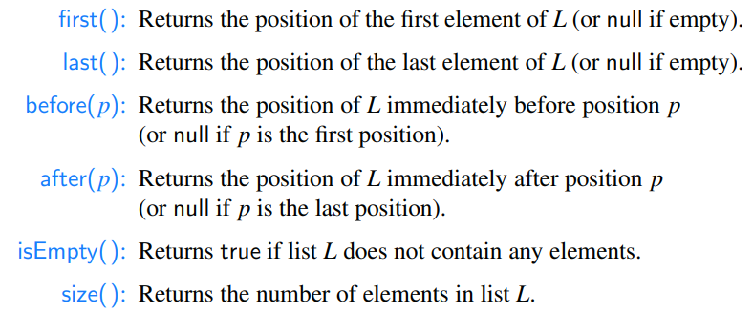

Note: first() and last() return the position, not the element.

The first element: first().getElement().

Traversing a Positional List

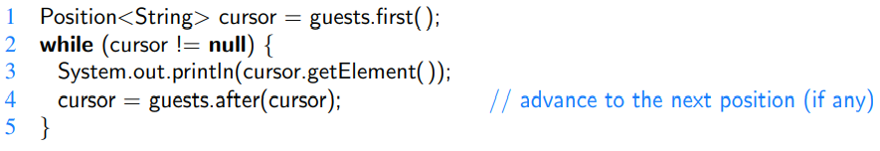

[cursor == null, ha tulmentunk az utolso elemen is.]

Update methods of the Positional List:

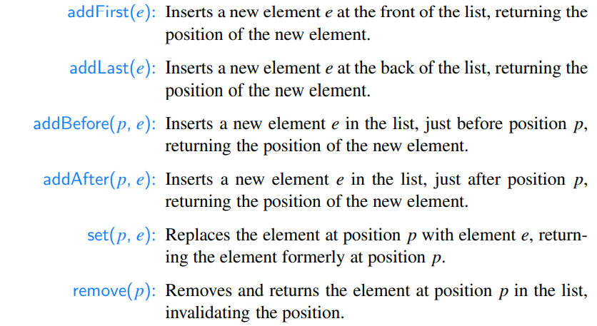

Example Usage:

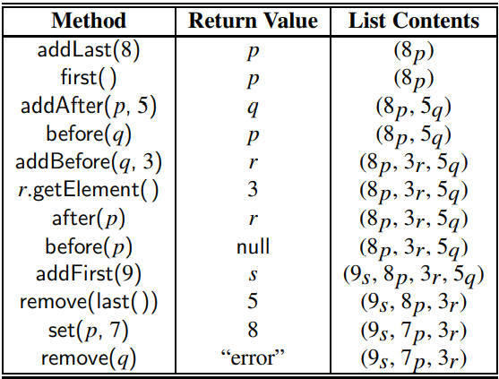

The Position Interface

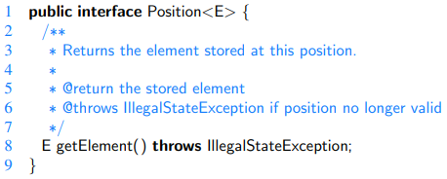

The Positional List Interface

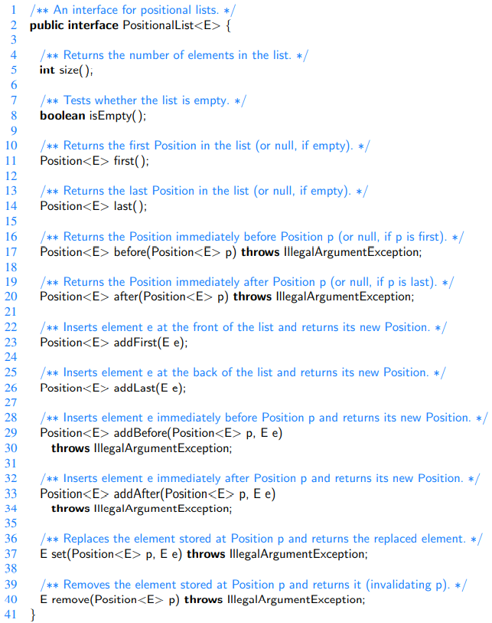

Doubly Linked List Implementation of the PositionalList

The *nodes* are the *positions*.

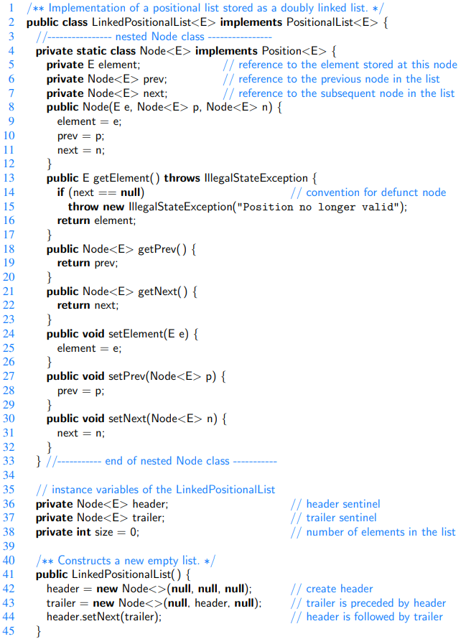

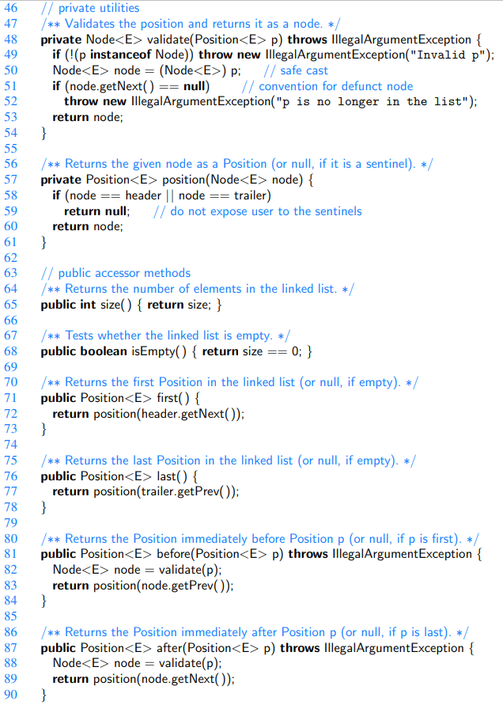

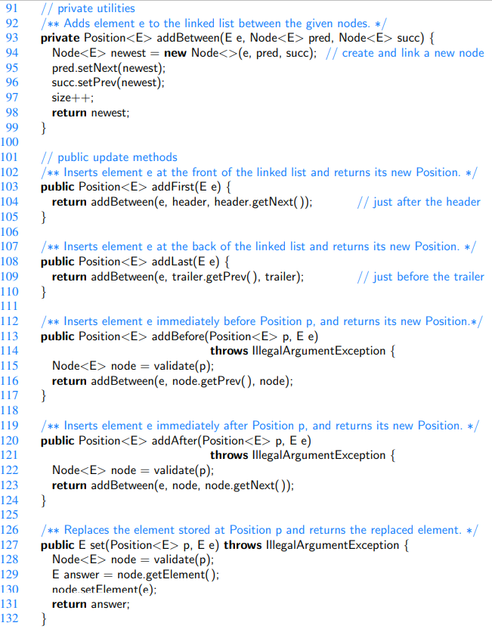

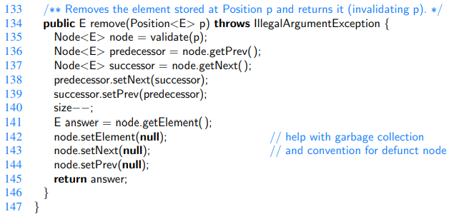

Time and Space Complexity of the LinkedPositionalList class

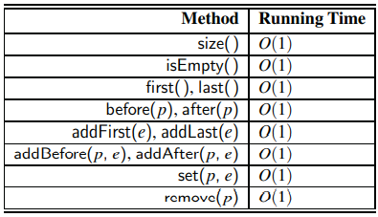

The space usage is O(n).

Implementing a Positional List with an Array

Remember that positions in a positional list should always be defined relative to their neighboring positions, not their indices.

We recommend the following representation. Instead of storing the elements of L directly in array A, we store a new kind of position object in each cell of A. A position p stores the element e as well as the current index i of that element within the list:

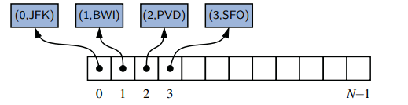

In this array implementation of a sequence, the addFirst, addBefore, addAfter, and remove methods take O(n) time, because we have to shift position objects to make room for the new position or to fill in the hole created by the removal of the old position (just as in the insert and remove methods based on index). All the other position-based methods take O(1) time.

Iterators

Methods of the java.util.Iterator:

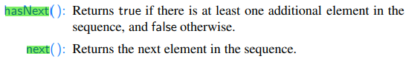

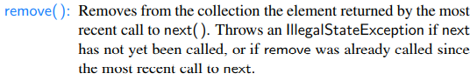

[The remove() method is optionally supported by some iterators.]

An example of iteration:

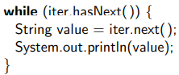

The Iterable Interface

It has one method:



Java’s for-each

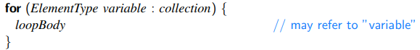

This is a short form of the following:

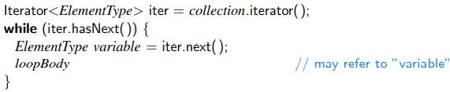

The iterator’s remove method cannot be invoked when using the for-each loop syntax. Instead, we must explicitly use an iterator. As an example, the following loop can be used to remove all negative numbers from an ArrayList of floating-point values.

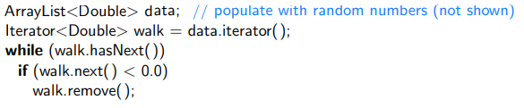

Implementing Iterators

A **snapshot iterator** maintains its own private copy of the sequence of elements, which is constructed at the time the iterator object is created. It effectively records a “snapshot” of the sequence of elements at the time the iterator is created, and is therefore unaffected by any subsequent changes to the primary collection that may occur. Implementing snapshot iterators tends to be very easy, as it requires a simple traversal of the primary structure. The downside of this style of iterator is that it requires O(n) time and O(n) auxiliary space.

A **lazy iterator** is one that does not make an upfront copy, instead performing a piecewise traversal of the primary structure only when the next( ) method is called to request another element. The advantage of this style of iterator is that it can typically be implemented so the iterator requires only O(1) space and O(1) construction time. One downside (or feature) of a lazy iterator is that its behavior is affected if the primary structure is modified (by means other than by the iterator’s own remove method) before the iteration completes.

Iterations with the ArrayList class

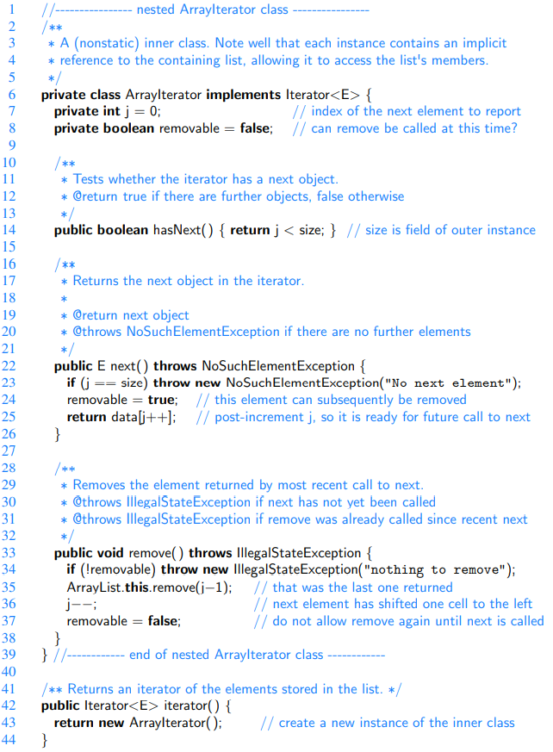

Iterations with the LinkedPositionalList class

A question is whether to support iteration of the elements of the list or the positions of the list.

We will implement both. iterator() and positions().

Implemented in a way that users can iterate by:

.

For this syntax to be legal, the return type of positions( ) must be Iterable.

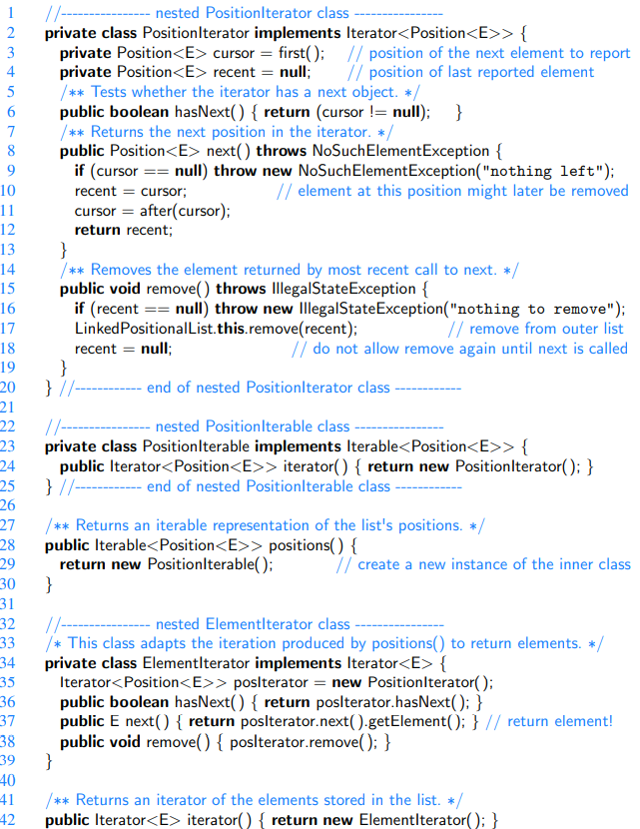

General Trees

A node is **external** if it has no children.

A node is **internal** if it has one or more children.

External nodes are also known as **leaves**.

A node u is an **ancestor** of a node v if u = v or u is an ancestor of the parent of v.

Conversely, we say that a node v is a **descendant** of a node u if u is an ancestor of v.

An **edge** of tree T is a pair of nodes (u,v) such that u is the parent of v, or vice versa.

A **path** of T is a sequence of nodes such that any two consecutive nodes in the sequence form an edge.

A tree is **ordered** if there is a meaningful linear order among the children of each node; that is, we purposefully identify the children of a node as being the first, second, third, and so on. Such an order is usually visualized by arranging siblings left to right, according to their order.

Let p be a position within tree T. The **depth** of p is the number of ancestors of p, other than p itself. Recursively:

- If p is the root, then the depth of p is 0.

- Otherwise, the depth of p is one plus the depth of the parent of p.

The **height** of a tree is the maximum of the depths of its positions (or zero, if the tree is empty). The position with maximum depth must be a leaf. Recursively:

- If p is a leaf, then the height of p is 0.

- Otherwise, the height of p is one more than the maximum of the heights of p’s children.

The Tree Abstract Data Type

As we did with positional lists, we define a tree ADT using the concept of a position as an abstraction for a node of a tree.

A position object for a tree supports the methods:

Accessor methods:

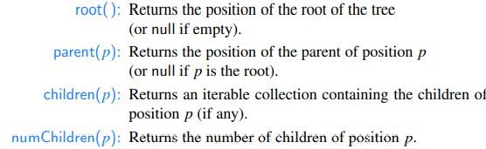

Query methods:

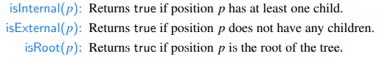

General methods:

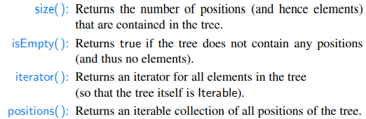

A Tree Interface in Java

Note that we declare the Tree interface to formally extend Java’s Iterable interface (and we include a declaration of the required iterator( ) method).

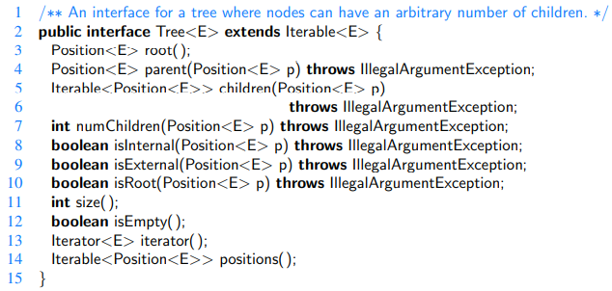

An AbstractTree Base Class in Java

While an interface is a type definition that includes public declarations of various methods, an interface cannot include definitions for any of those methods. In contrast, an abstract class may define concrete implementations for some of its methods, while leaving other abstract methods without definition.

[e.g. An AbstractList class implements some of the functionality of the List interface.]

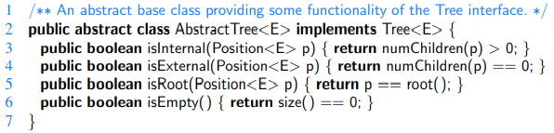

Computing Depth and Height

Depth method, as implemented within the AbstractTree class

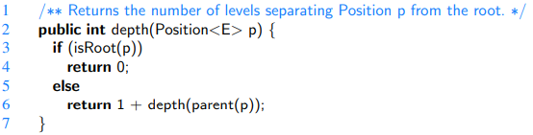

The running time of depth(p) for position p is O(dp + 1), where dp denotes the depth of p in the tree, because the algorithm performs a constant-time recursive step for each ancestor of p. Thus, algorithm depth(p) runs in O(n) worst-case time, where n is the total number of positions of T, because a position of T may have depth n − 1 if all nodes form a single branch. Although such a running time is a function of the input size, it is more informative to characterize the running time in terms of the parameter dp, as this parameter may be much smaller than n

Height method

This is bad:

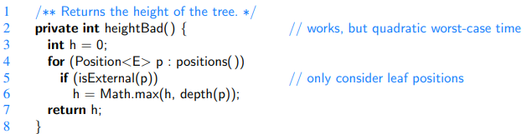

Because heightBad calls algorithm depth(p) on each leaf of T, its running time is

,

where L is the set of leaf positions of T. In the worst case, the sum  is proportional to n^2.

We can make it O(n), if we use the recursive definition of the height.

Proposition: The height of the root of a nonempty tree T, according to the recursive definition, equals the maximum depth among all leaves of tree T.

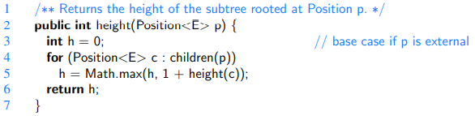

It is important to understand why method height is more efficient than method heightBad. The algorithm is recursive, and it progresses in a top-down fashion. If the method is initially called on the root of T, it will eventually be called once for each position of T. This is because the root eventually invokes the recursion on each of its children, which in turn invokes the recursion on each of their children, and so on.

We can determine the running time of the recursive height algorithm by summing, over all the positions, the amount of time spent on the nonrecursive part of each call. In our implementation, there is a constant amount of work per position, plus the overhead of computing the maximum over the iteration of children. Although we do not yet have a concrete implementation of children(p), we assume that such an iteration is executed in O(cp + 1) time, where cp denotes the number of children of p. Algorithm height(p) spends O(cp+1) time at each position p to compute the maximum, and its overall running time is

.

Proposition: Let T be a tree with n positions, and let cp denote the number of children of a position p of T. Then, summing over the positions of T, ∑p cp = n−1.

Justification: Each position of T, with the exception of the root, is a child of another position, and thus contributes one unit to the above sum.

By the above proposition, the running time of algorithm *height*, when called on the root of T, is O(n), where n is the number of positions of T.

Binary Trees

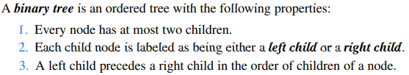

The subtree rooted at a left or right child of an internal node v is called a **left subtree** or **right subtree**, respectively, of v.

A binary tree is **proper** if each node has either zero or two children. Some people also refer to such trees as being **full binary** trees. Thus, in a proper binary tree, every internal node has exactly two children.

A binary tree that is not proper is **improper**.

Example: ((((3+1) ∗ 3)/((9−5)+2)) − ((3 ∗ (7−4))+6))

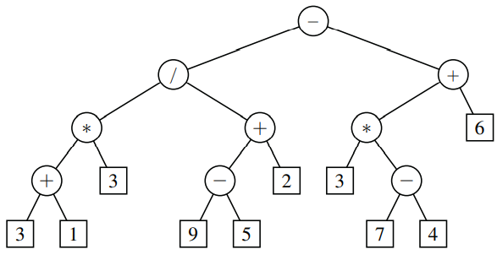

The value associated with the internal node labeled “/” is 2.

A Recursive Binary Tree Definition

A binary tree is either:

- An empty tree, or

- A nonempty tree having a root node r, which stores an element, and two binary trees that are respectively the left and right subtrees of r. We note that one or both of those subtrees can be empty by this definition.

The Binary Tree Abstract Data Type

A binary tree is a specialization of a tree that supports three additional accessor methods:

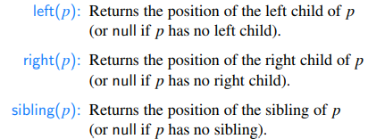

The BinaryTree Interface

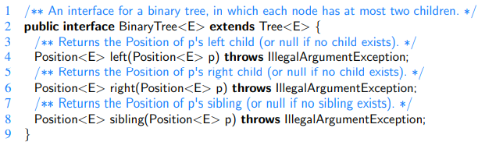

The AbstractBinaryTree Base Class

It provides additional concrete methods that can be derived from the newly declared left and right methods (which remain abstract).

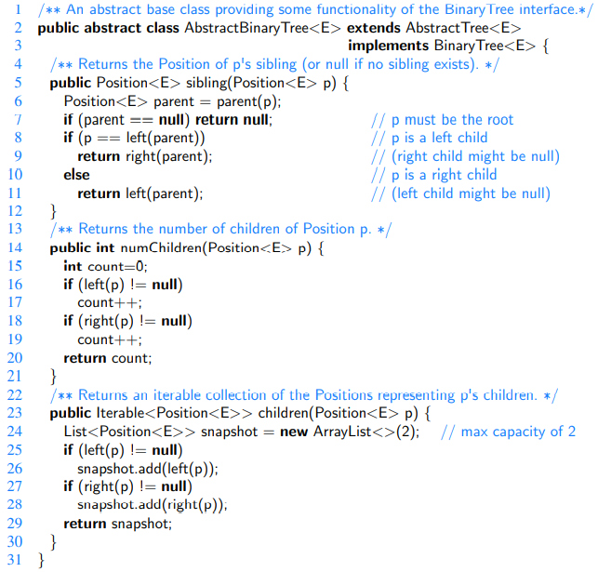

Properties of Binary Trees

Level d has at most 2d nodes.

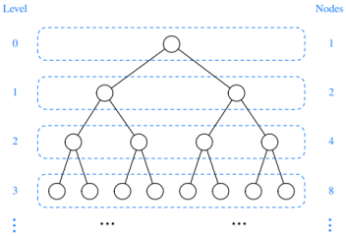

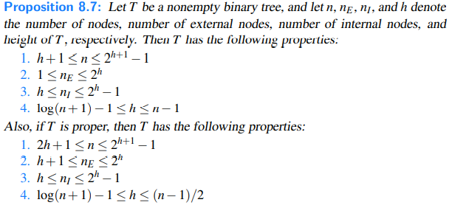

Relating Internal Nodes to External Nodes in a Proper Binary Tree



Implementing Trees

Linked Structure for Binary Trees

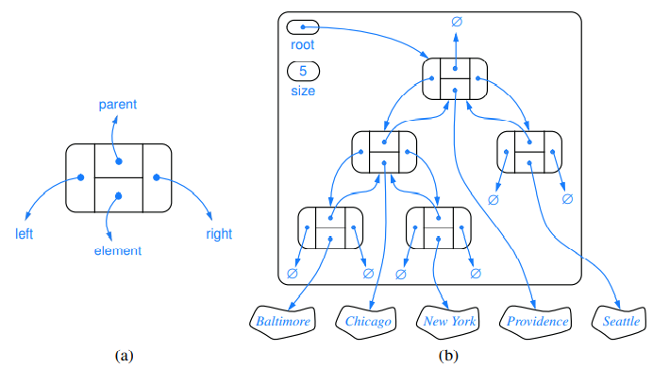

Update methods:

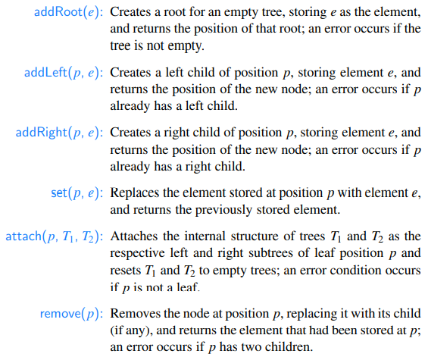

Each of these can be implemented in O(1) worst-case time with our linked representation.

Java Implementation of a Linked Binary Tree Structure

**Factory Method** **Pattern** is a design pattern that provides an interface for creating objects in a superclass, but allows subclasses to alter the type of objects that will be created.

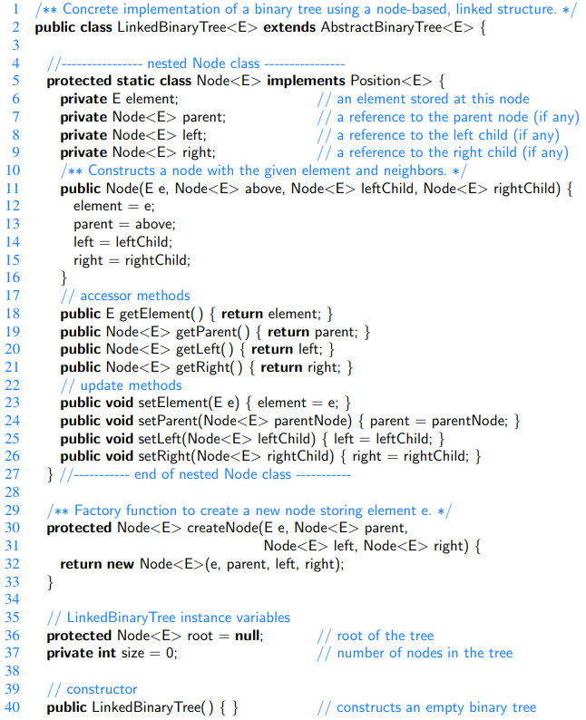

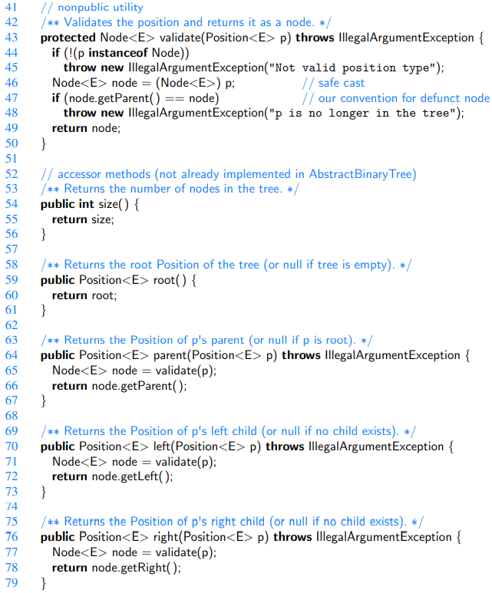

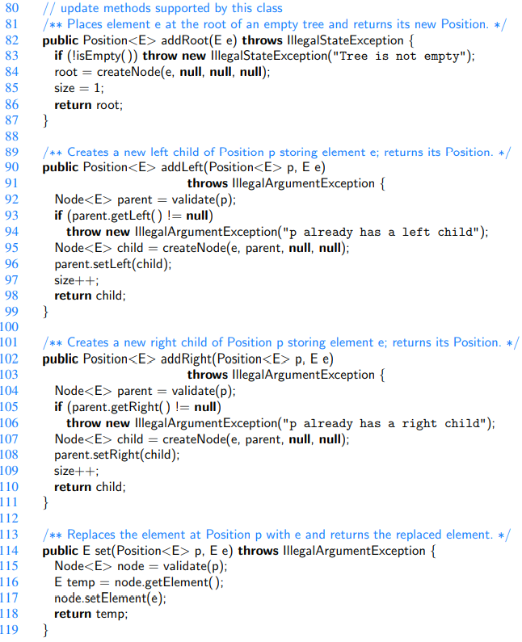

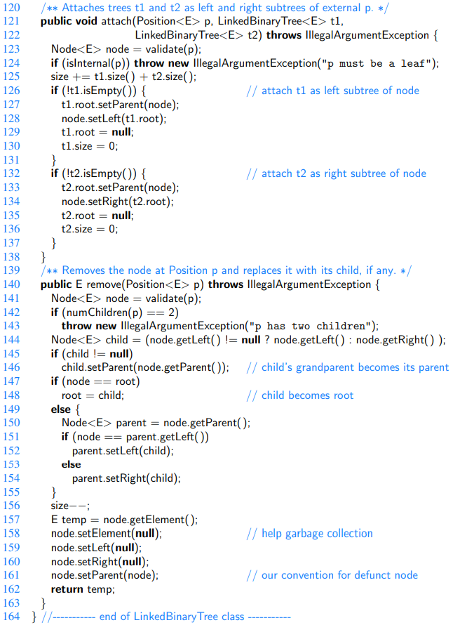

Time and Space Complexity of the Linked Binary Tree Implementation

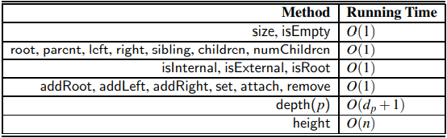

The space usage is O(n). n is the number of nodes.

Array-Based Representation of a Binary Tree

Level numbering function f().

For every position p of T, let f(p) be the integer defined as follows. • If p is the root of T, then f(p) = 0.

• If p is the left child of position q, then f(p) = 2 f(q) +1.

• If p is the right child of position q, then f(p) = 2 f(q) +2.

It numbers the positions on each level of T in increasing order from left to right.

Note well that the level numbering is based on potential positions within a tree, not the actual shape of a specific tree, so they are not necessarily consecutive.

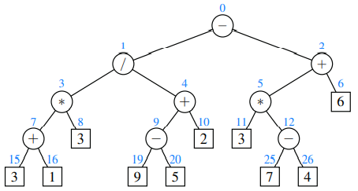

The function f(p) gives the index where p is stored.

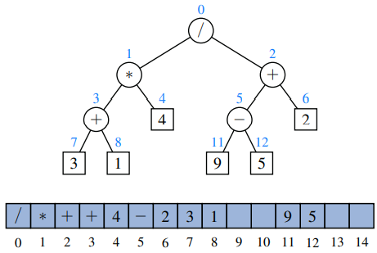

There are drawbacks. Space inefficiency; and update operation inefficiency e.g. removing a node takes O(n) time, because after removing the node, we have to shift all the others.

Linked Structure for General Trees

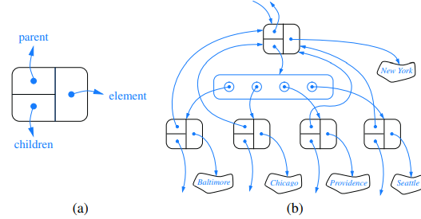

Performance of the implementation of a general tree using a linked structure

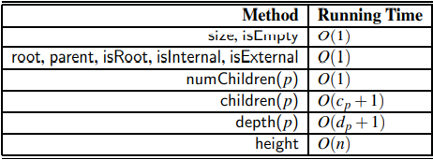

The space usage is O(n).

Tree Traversal Algorithms

Preorder traversal

In a preorder traversal of a tree T, the root of T is visited first and then the subtrees rooted at its children are traversed recursively. If the tree is ordered, then the subtrees are traversed according to the order of the children.

Example of a preorder traversal of an ordered tree:

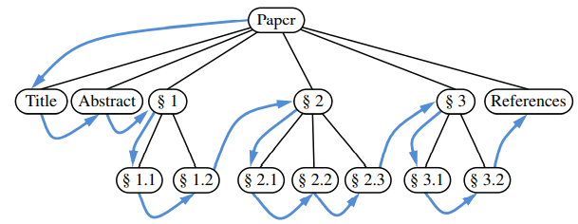

Postorder traversal

It recursively traverses the subtrees rooted at the children of the root first, and then visits the root.

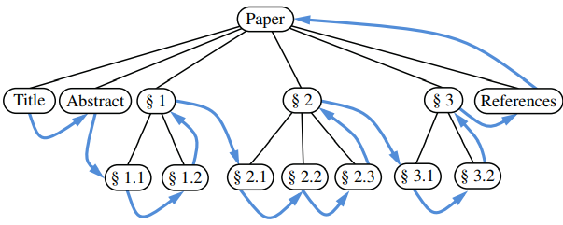

Running Time Analysis

Both preorder and postorder traversal algorithms are efficient ways to access all the positions of a tree. The analysis of either of these traversal algorithms is similar to that of algorithm *height*. At each position p, the nonrecursive part of the traversal algorithm requires time O(cp +1), where cp is the number of children of p, under the assumption that the “visit” itself takes O(1) time. The overall running time for the traversal of tree T is O(n), where n is the number of positions in the tree. This running time is asymptotically optimal since the traversal must visit all n positions of the tree.

Breadth-First Tree Traversal

We visit all the positions at depth d before we visit the positions at depth d + 1.

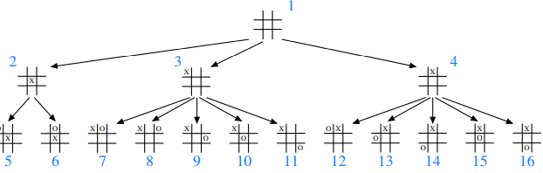

The algorithm for breadthfirst traversal implementation

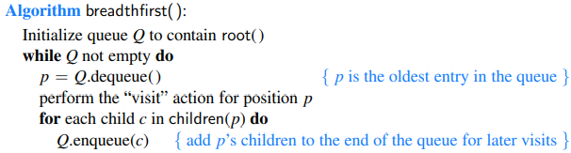

Inorder Traversal of a Binary Tree

This one is specifically for binary trees, while the previous ones work with general trees as well.

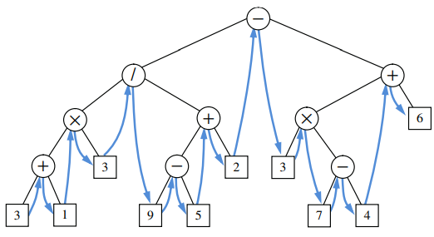

An important application of inorder traversal: binary search trees

Let S be a set whose unique elements have an order relation. For example, S could be a set of integers. A **binary search tree** for S is a proper binary tree T such that, for each internal position p of T:

• Position p stores an element of S, denoted as e(p).

• Elements stored in the left subtree of p (if any) are less than e(p).

• Elements stored in the right subtree of p (if any) are greater than e(p).

The above properties assure that an *inorder* traversal of a binary search tree T visits the elements in *nondecreasing* order.

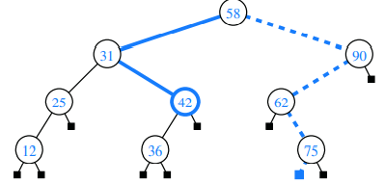

Note that the *running time* of searching in a binary search tree T is proportional to the height of T. Recall from Proposition 8.7 that the height of a binary tree with n nodes can be as small as log(n+1)−1 or as large as n−1. Thus, binary search trees are most efficient when they have small height.

Implementing Tree Traversals in Java

Supporting methods:



An iteration of all elements of a tree can easily be produced if we have an iteration of all positions of that tree:

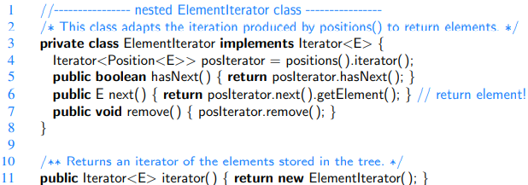

Defining preorder as the default traversal algorithm for the public positions method of an abstract tree:



We want to implement this preorder() method. For this we will create a preorderSubtree recursive method:

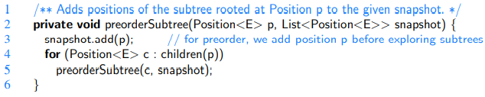

It is a recursive subroutine for performing a preorder traversal of the subtree rooted at position p of a tree. This code should be included within the body of the AbstractTree class.

The public preorder method, shown in Code Fragment 8.19, has the responsibility of creating an empty list for the snapshot buffer, and invoking the recursive method at the root of the tree (assuming the tree is nonempty). We rely on a java.util.ArrayList instance as an Iterable instance for the snapshot buffer:

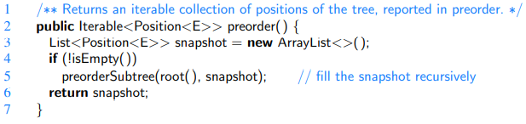

This is a public method that performs a preorder traversal of an entire tree. This code should be included within the body of the AbstractTree class.

Postorder Traversal

We implement a postorder traversal using a similar design as we used for a preorder traversal. The only difference is that a “visited” position is not added to a postorder snapshot until after all of its subtrees have been traversed.

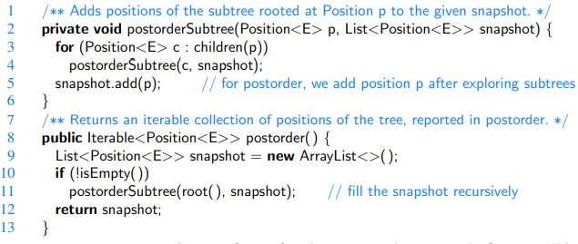

Breadth-First Traversal

Any implementation of the queue ADT would suffice, we chose LinkedQueue.

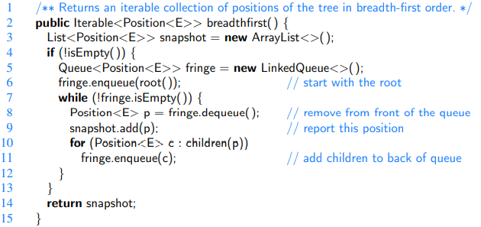

Inorder Traversal for Binary Trees

We include its definition within the body of the AbstractBinaryTree class, because it only works for binary trees.

Support for performing an inorder traversal of a binary tree, and for making that order the default traversal for binary trees:

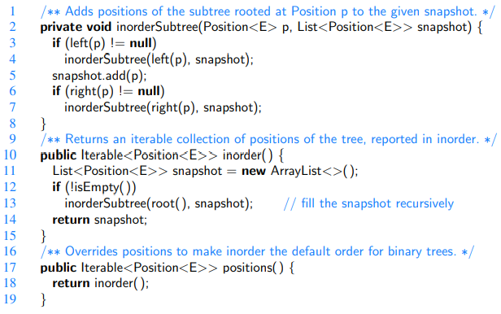

Applications of Tree Traversals

Preorder traversal: Table of contents

Eg.:

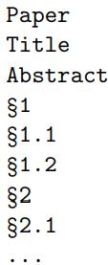

Tehat csak ezt kell csinalni:

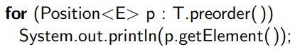

We could make it indented, like this:

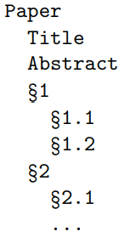

The code could be:



But it would result in O(n^2) instead of O(n).

Solution: Recursion

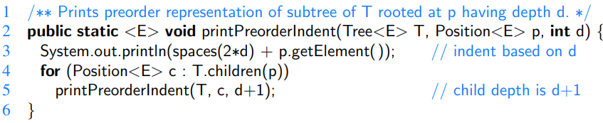

And we use this to call this method:



We can put labels (numbering) at the beginning of each row, like this:

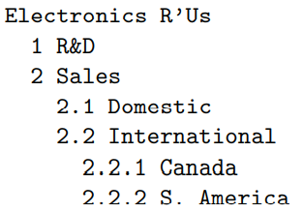

Code for this:

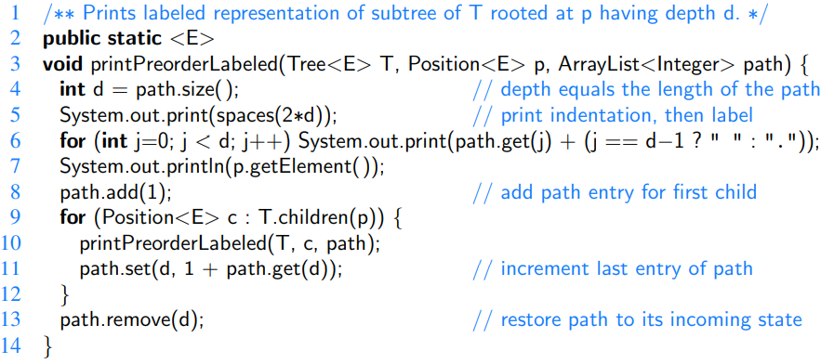

Postorder traversal: file-system disc space

(As we cannot effectively compute the total space used by a directory until after we know the space that is used by its children directories.)

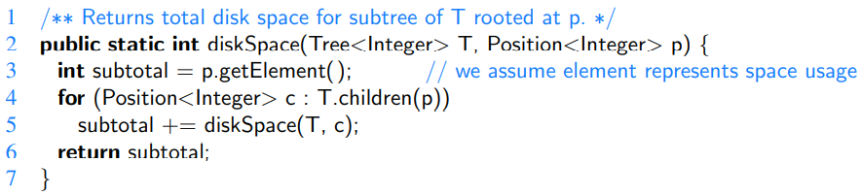

Parenthetic Representation of a Tree

The parenthetic string representation P(T) of tree T is recursively defined. If T consists of a single position p, then P(T) = p.getElement(). Otherwise, it is defined recursively as



where p is the root of T and T1,T2,...,Tk are the subtrees rooted at the children of p, which are given in order if T is an ordered tree. We are using “+” here to denote string concatenation.

Example:

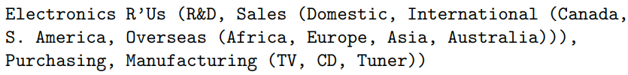

Code:

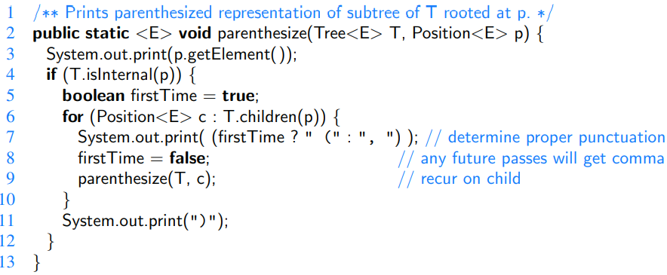

Using Inorder Traversal for Tree Drawing

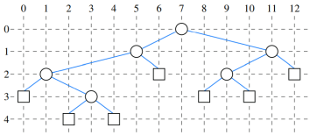

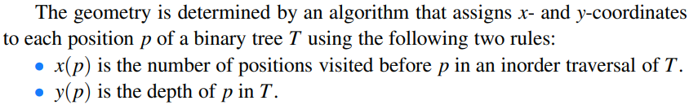

Code:

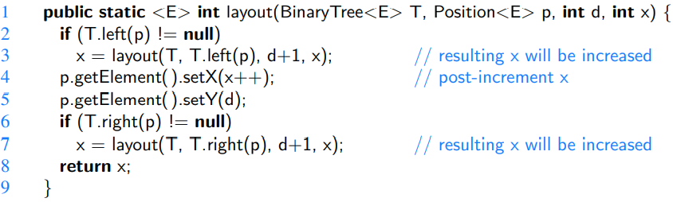

Euler Tours

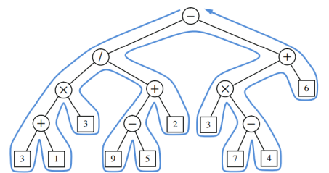

The complexity of the walk is O(n), for a tree with n nodes, because it progresses exactly two times along each of the n − 1 edges of the tree—once going downward along the edge, and later going upward along the edge.

We need to unify the traversal algorithms for this.

To unify the concept of preorder and postorder traversals, we can view there being two notable “visits” to each position p:

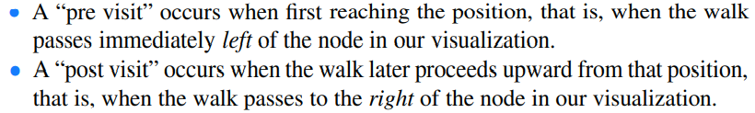

Pseudo-Code:

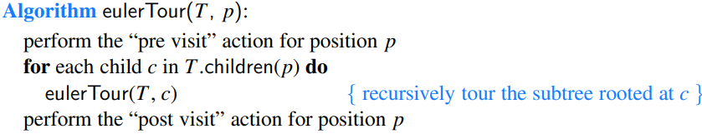

For a binary tree:

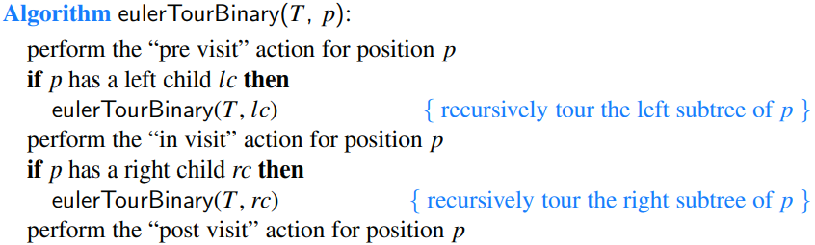

The Priority Queue ADT

This is a collection of prioritized elements that allows arbitrary element insertion, and allows the removal of the element that has first priority. When an element is added to a priority queue, the user designates its priority by providing an associated key. The element with the minimal key will be the next to be removed from the queue (thus, an element with key 1 will be given priority over an element with key 2). Although it is quite common for priorities to be expressed numerically, any Java object may be used as a key, as long as there exists means to compare any two instances a and b, in a way that defines a natural order of the keys.

Methods:

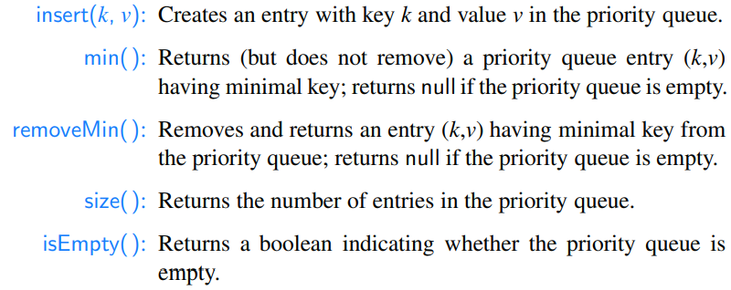

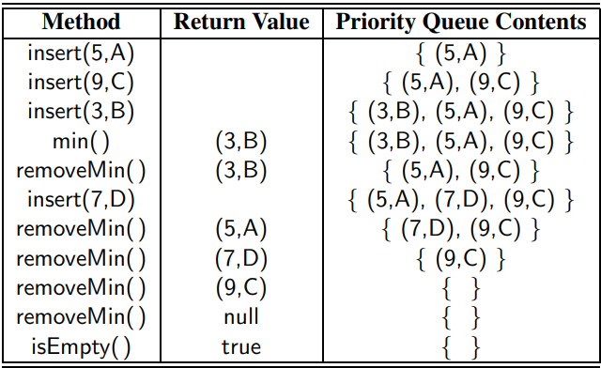

Implementation of Priority Queue

We must keep track of both an element and its key.

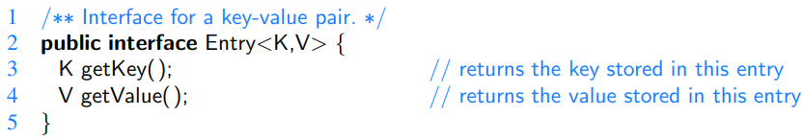

Interface for the Priority Queue:

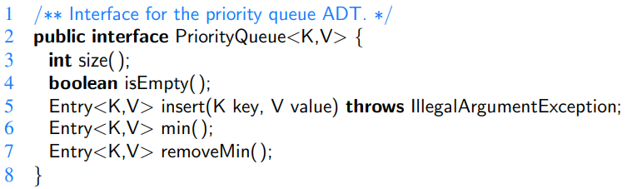

Comparing Keys

In defining the priority queue ADT, we can allow any type of object to serve as a key, but we must be able to compare keys to each other in a meaningful way.

The Comparable Interface

Natural ordering. (Eg. Numbers or characters)

The syntax a.compareTo(b) must return an integer i with the following meaning:

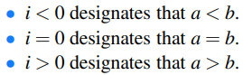

The Comparator Interface

Instead of the natural ordering, we can define how we want to order. Eg. By the length of the words.

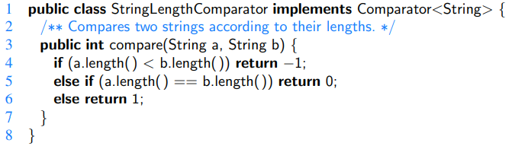

Comparators and the Priority Queue ADT

For a general and reusable form of a priority queue, we allow a user to choose any key type and to send an appropriate comparator instance as a parameter to the priority queue constructor.

For convenience, we also allow a default priority queue to instead rely on the natural ordering for the given keys (assuming those keys come from a comparable class):

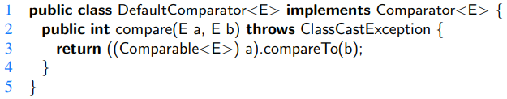

The AbstractPriorityQueue Base Class

To manage technical issues common to all our priority queue implementations, we define an abstract base class.

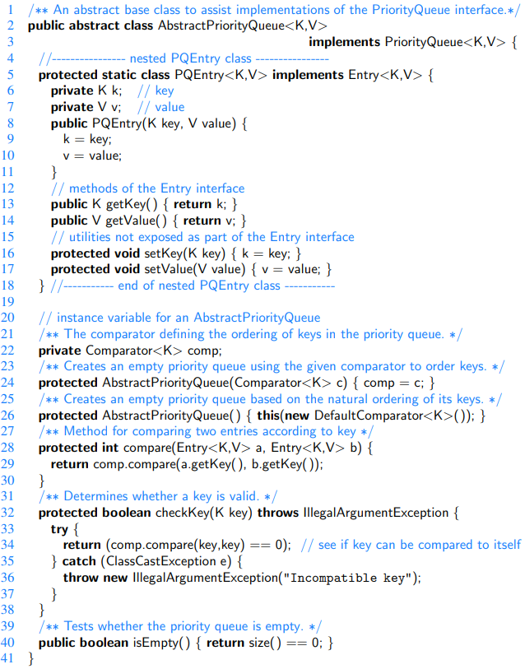

Implementing a Priority Queue with an Unsorted [Linked] List

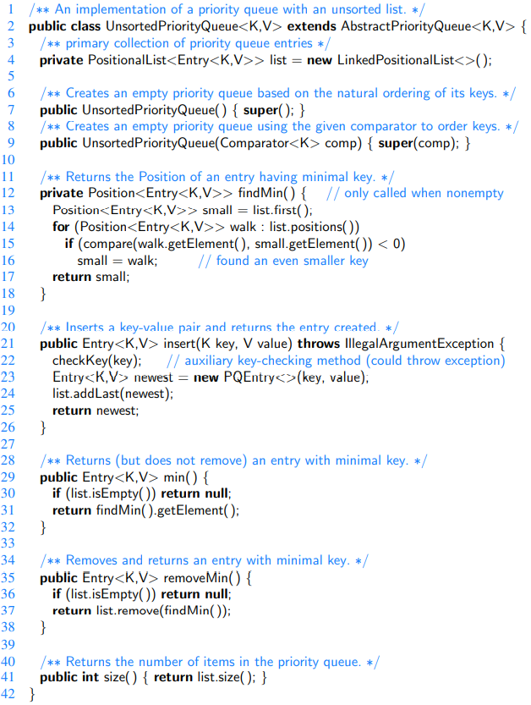

Implementing a Priority Queue with a Sorted List

Our next implementation of a priority queue also uses a positional list, yet maintains entries sorted by nondecreasing keys. This ensures that the first element of the list is an entry with the smallest key.

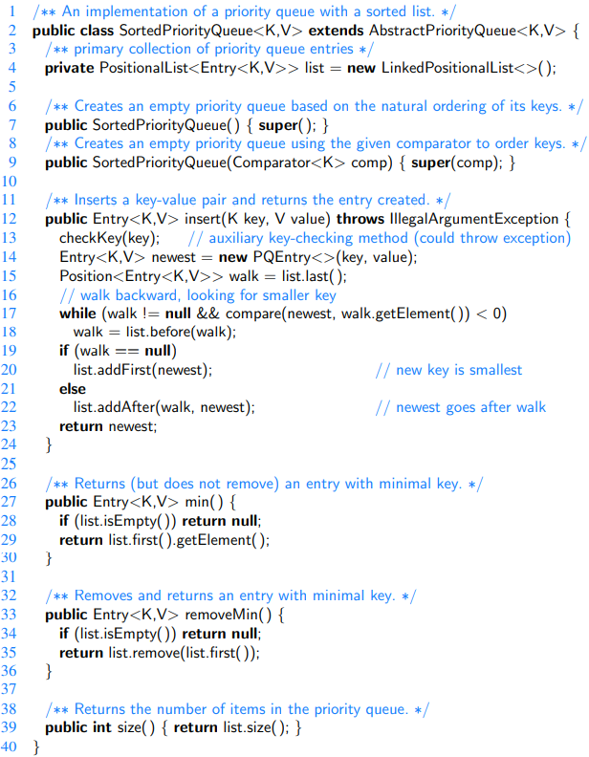

Time Complexities:

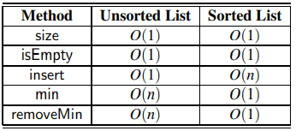

Heaps

A heap is a binary tree T that stores entries at its positions, and that satisfies two additional properties: a relational property defined in terms of the way keys are stored in T and a structural property defined in terms of the shape of T itself. The relational property is the following:



For the sake of efficiency, as will become clear later, we want the heap T to have as small a height as possible. We enforce this requirement by insisting that the heap T satisfy an additional structural property; it must be what we term **complete**:

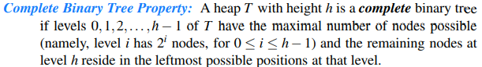

Example of a heap storing 13 entries with integer keys. The last position is the one storing entry (13,W ):

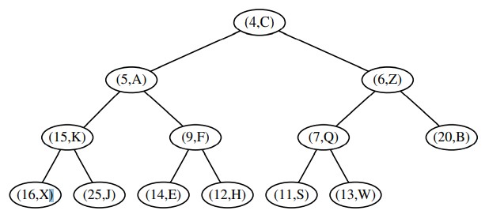

This tree is complete because levels 0, 1, and 2 are full, and the six nodes in level 3 are in the six leftmost possible positions at that level.

The Height of a Heap



Implementing a Priority Queue with a Heap

We will use the composition pattern to store key-value pairs as entries in the heap.

Insertion into a Heap

Let us consider how to perform insert(k, v) on a priority queue implemented with a heap T. We store the pair (k,v) as an entry at a new node of the tree. To maintain the complete binary tree property, that new node should be placed at a position p just beyond the rightmost node at the bottom level of the tree, or as the leftmost position of a new level, if the bottom level is already full (or if the heap is empty).

Up-Heap Bubbling After an Insertion

Insertion of a new entry with key 2 into the heap [of the previous figure]: (a) initial heap; (b) after adding a new node; (c and d) swap to locally restore the partial order property; (e and f) another swap; (g and h) final swap.

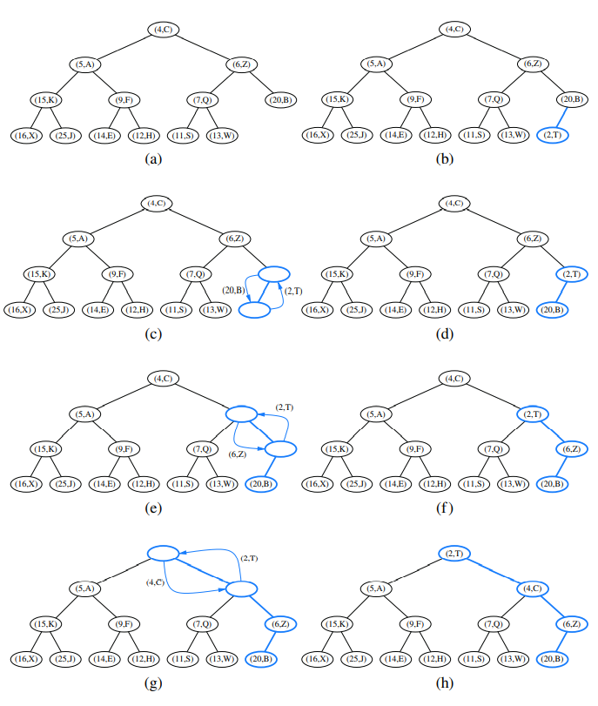

Removal of an Entry

Removal of the entry with the smallest key from a heap: (a and b) deletion of the last node, whose entry gets stored into the root; (c and d) swap to locally restore the heap-order property; (e and f) another swap; (g and h) final swap.

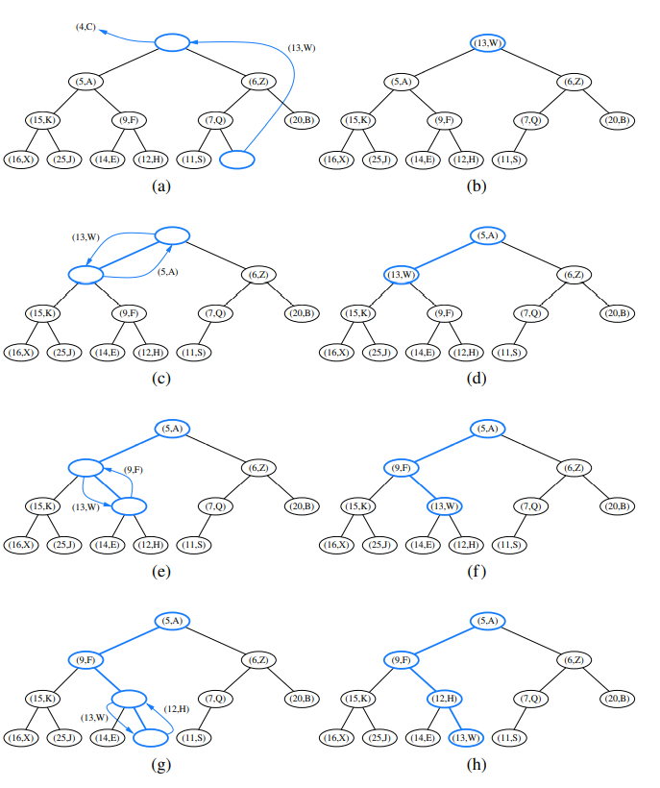

Array-Based Representation of a Complete Binary Tree

The array-based representation of a binary tree is especially suitable for a complete binary tree. We recall that in this implementation, the elements of the tree are stored in an array-based list A such that the element at position p is stored in A with index equal to the level number f(p) of p, defined as follows:

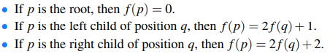

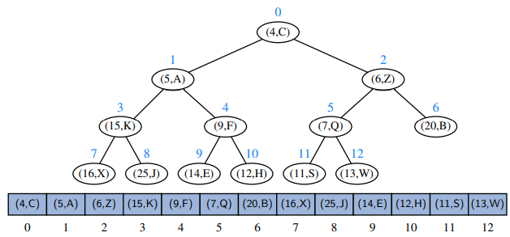

The array-based heap representation avoids some complexities of a linked tree structure. Specifically, methods insert and removeMin depend on locating the last position of a heap. With the array-based representation of a heap of size n, the last position is simply at index n−1. Locating the last position in a heap implemented with a linked tree structure requires more effort.

If the size of a priority queue is not known in advance, use of an array-based representation does introduce the need to dynamically resize the array on occasion, as is done with a Java ArrayList. The space usage of such an array-based representation of a complete binary tree with n nodes is O(n), and the time bounds of methods for adding or removing elements become amortized.

Java Heap Implementation [Java implementation of a heap-based priority queue]

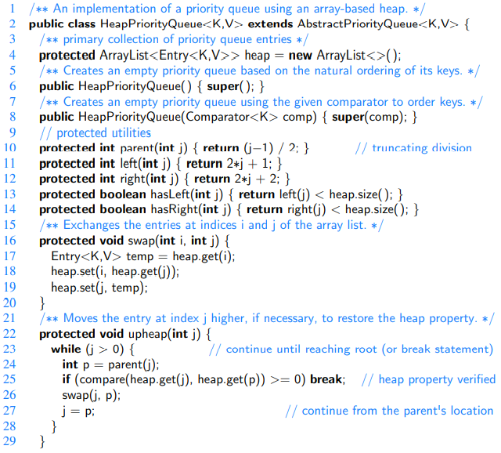

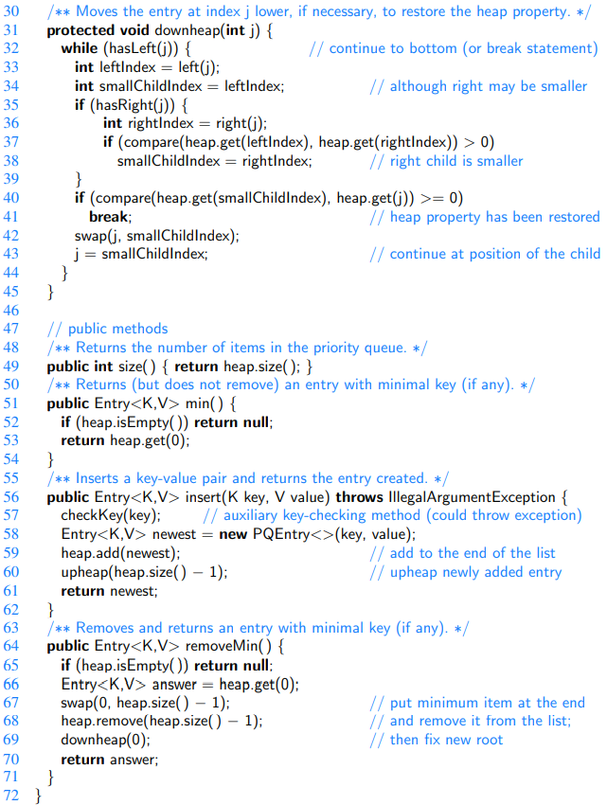

Time Complexities:

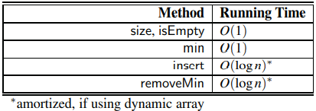

Bottom-Up Heap Construction

If we start with an initially empty heap, n successive calls to the insert operation will run in O(n log n) time in the worst case. However, if all n key-value pairs to be stored in the heap are given in advance, such as during the first phase of the heap-sort algorithm (introduced in a later chapter), there is an alternative bottom-up construction method that runs in O(n) time.

Bottom-up construction of a heap with 15 entries: (a and b) we begin by constructing 1-entry heaps on the bottom level; (c and d) we combine these heaps into 3-entry heaps; (e and f) we build 7-entry heaps; (g and h) we create the final heap. The paths of the down-heap bubblings are highlighted in (d, f, and h). For simplicity, we only show the key within each node instead of the entire entry.

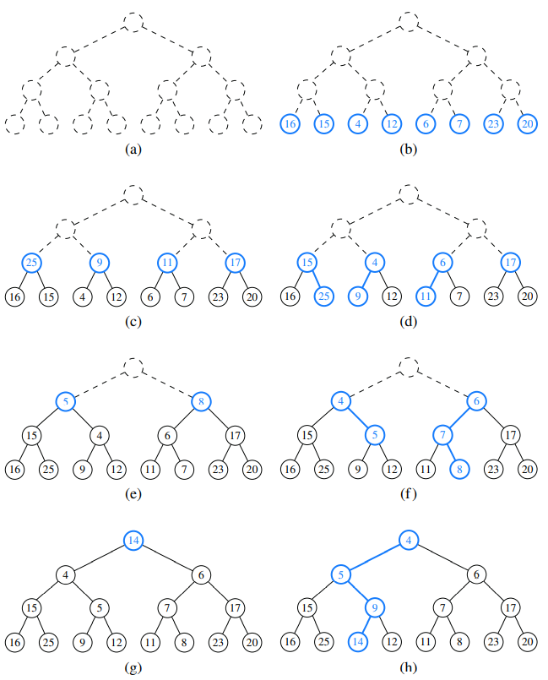

Java Implementation of a Bottom-Up Heap Construction

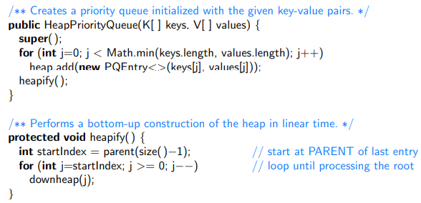

Time Complexity



Using the java.util.PriorityQueue Class

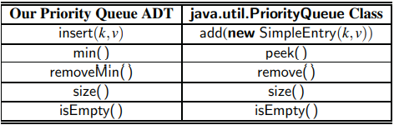

Adaptable Priority Queues

The methods of the priority queue ADT given in Section 9.1.2 are sufficient for most basic applications of priority queues, such as sorting. However, there are situations in which additional methods would be useful, as shown by the scenarios below involving the standby airline passenger application.

• A standby passenger with a pessimistic attitude may become tired of waiting and decides to leave ahead of the boarding time, requesting to be removed from the waiting list. Thus, we would like to remove from the priority queue the entry associated with this passenger. Operation removeMin does not suffice since the passenger leaving does not necessarily have first priority. Instead, we want a new operation, *remove*, that removes an arbitrary entry.

• Another standby passenger finds her gold frequent-flyer card and shows it to the agent. Thus, her priority has to be modified accordingly. To achieve this change of priority, we would like to have a new operation *replaceKey* allowing us to replace the key of an existing entry with a new key.

• Finally, a third standby passenger notices her name is misspelled on the ticket and asks it to be corrected. To perform this change, we need to update the passenger’s record. Hence, we would like to have a new operation *replaceValue*, allowing us to replace the value of an existing entry with a new value.

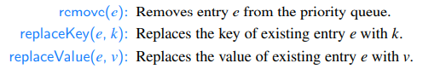

Location-Aware Entries

Representing a heap using an array of location-aware entries. The third field of each entry instance corresponds to the index of that entry within the array. Identifier token [blue] is presumed to be an entry reference in the user’s scope:

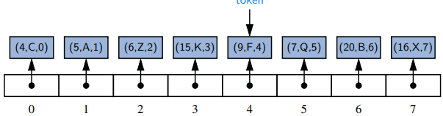

The result of a call to removeMin( ):[Identifier *token* continues to reference the same entry as in the original configuration, but the placement of that entry in the array has changed, as has the third field of the entry.]

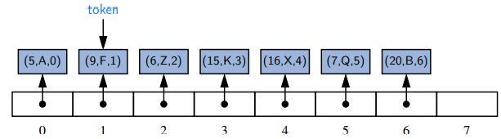

Implementing an Adaptable Priority Queue

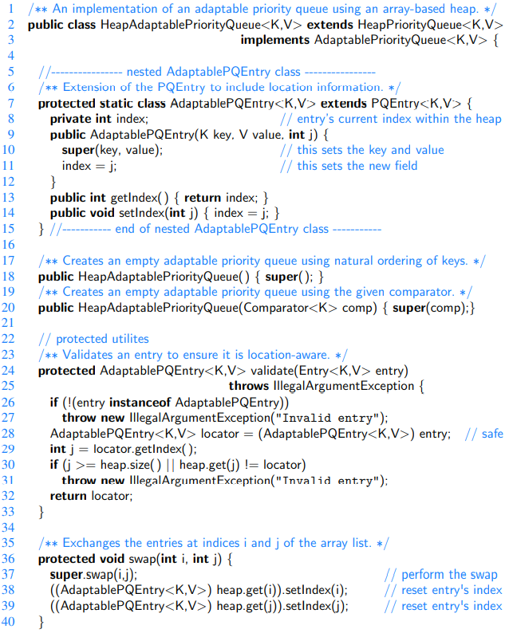

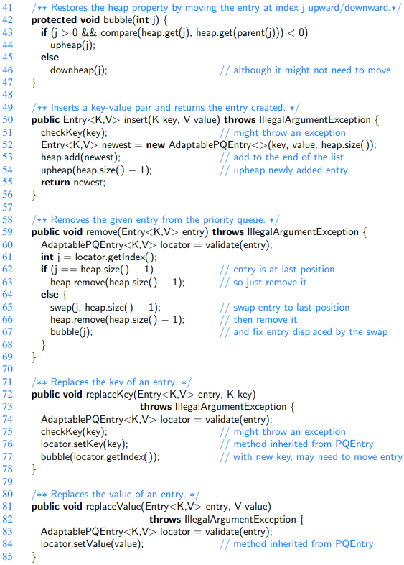

Time Complexities:

